Ideation Phase
Empathize & Discover

Date | 12 October 2026
Team ID | SWUID2026403825
Project Name | StaffSync - Modern human resource management solution
Maximum Marks | 4 Marks

Empathy Map Canvas:
Understand the needs, frustrations, and behaviours of HR professionals and employees managing employee records, attendance, leave requests, and workplace communication through a centralized HR management platform like StaffSync - Modern human resource management solution.
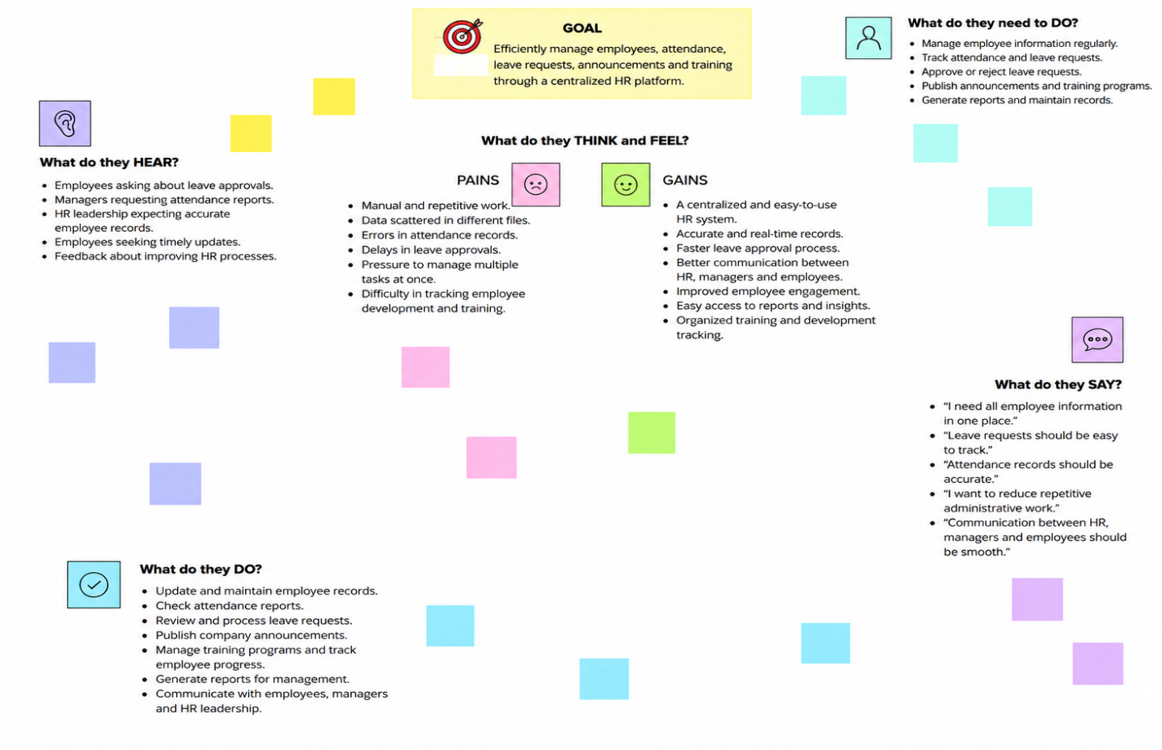

Reference: https://www.mural.co/templates/empathy-map-canvas

